**Title:**

How to maximize and minimize GUI objects in a mashup using jQuery

**Summary:**

It may happen sometimes that a mashup gets cluttered with many objects, and some of them can be small for reading, so users should be able to have the option to click on a button to maximize or minimize a given GUI object (Chart, KIP GUI, Table, etc.), something similar to the native behavior found in Qlik Sense applications when opened from the hub.

**Description:**

For usability purposes, we want to make it possible for users to expand / maximize GUI objects in a mashup, especially if the screen is cluttered and some GUI objects are hard to read. Masups depend heavily on HTML, CSS and JavaScript. Thus it is possible to use these technologies to make such functionality possible for GUI objects i.e. to be expandable (maximized and minimized) when needed.

**Resolution:**

The article provides code snippets on how to solve this issue (this will need some changes in HTML, JavaScript, and CSS). Kindly refer to code comments below in case something is not clear.

*HTML code:*

<!-- The GUI object we want to maximize and minimize is placed in a div tag along with a clickable button -->

<div id="max_min_container" style="border:solid;">

<button id="max_min_btn">Maximize</button>

<div id="QV01" class="qvobject"></div>

</div>

*JavaScript code (jQuery):*

//open apps -- inserted here --

var app = qlik.openApp('Flight Data Detail.qvf', config);

//get objects -- inserted here --

app.getObject('QV01','mmHDDX');

// Maximize and minimize code

$('#max_min_btn').click(function(e){

$('#max_min_container').toggleClass('fullscreen');

qlik.resize('QV01');

});

*CSS code:*

.fullscreen{

z-index: 9999;

width: 100%;

height: 100%;

position: absolute;

top: 0;

left: 0;

}

The screen shots below show the result, before and after clicking on the interactive button we added above in the HTML code.

Before

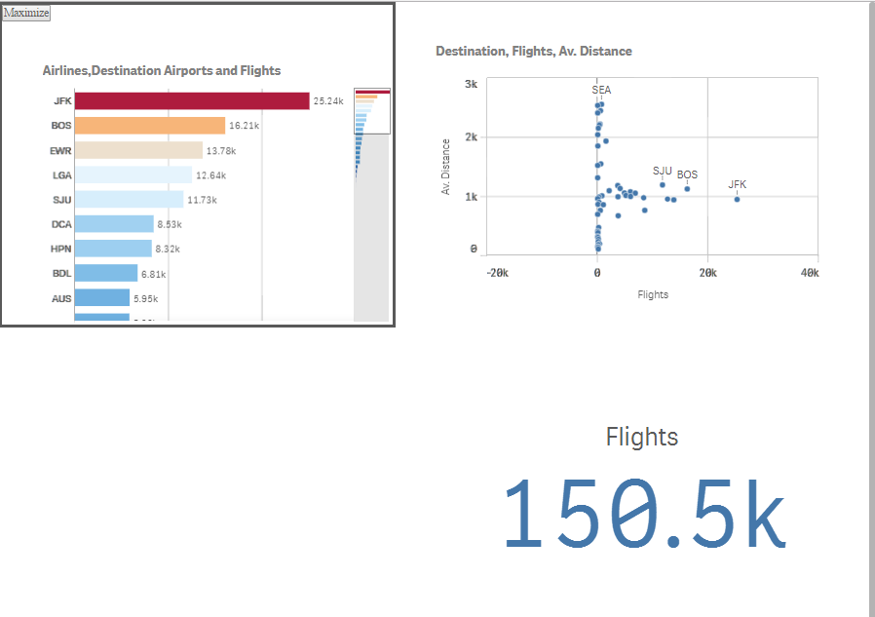

After

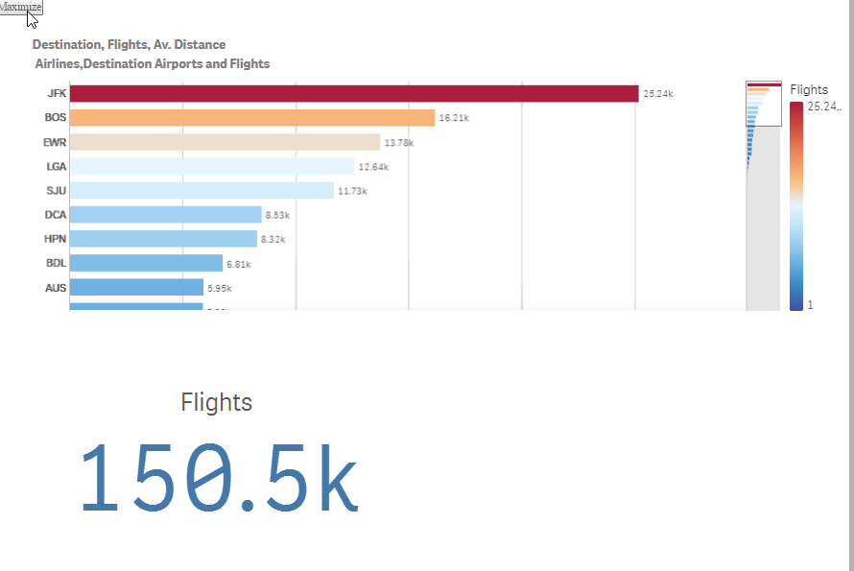

**Tags:**

Mashup, Toggle size, CSS, JavaScript, GUI, maximize, minimize, dev-hub